|  |
| --- |
|  |
| BackBase Web Assignment |
| Test Evaluation Report |
|  |
|  |
| 27/05/2021  1.0 |

Table of Contents

DOCUMENT INFORMATION 3

DOCUMENT PURPOSE 3

REVISION HISTORY 3

APPLICATION OVERVIEW 4

ASSUMPTIONS 4

TESTING SCOPE 4

IN SCOPE 4

OUT OF SCOPE 5

ITEMS NOT TESTED 5

TESTING STRATEGY 5

TESTING METRICS 6

No. of test cases planned vs executed 6

No. of test cases passed/failed 6

No. of defects identified and their Status & Severity 6

RISKS 6

TEST TOOLS 7

RECOMMENDATIONS 7

EXIT CRITERIA 7

DOCUMENT INFORMATION

DOCUMENT PURPOSE

Test Evaluation Report Document for Web Assignment Application

REVISION HISTORY

|  |  |  |  |  |
| --- | --- | --- | --- | --- |
| Version(s) | Date | Status | Revised By | Comments |
| 0.1 |  | Completed |  | First Draft |
|  |  |  |  |  |
|  |  |  |  |  |
|  |  |  |  |  |

APPLICATION OVERVIEW

Web Application Assignment - "BBlog" is a social blogging site, registered users can create, update and read the articles.

ASSUMPTIONS

The following assumptions were taken into consideration during Testing:

* Completion of unit testing.

TESTING SCOPE

IN SCOPE

Functional Testing for the following modules are in Scope:

|  |  |  |  |
| --- | --- | --- | --- |
| **Functions** | **Description** | **Existing** | **New** |
| Sign Up | The user should able to create an account using sign-up functionality. | Sign up and functionality are available |  |
| Sign In | The users should able to log in with a valid email id and password. | Sign-in pages are available and functionality is working. |  |
| CRUD Articles | The users should able to create, read, update and delete the articles. | All the CURD functionality are working as expected |  |
| CR*D Comments on articles (no updating required)the Comment | The users should able to create, read and delete the comments. | All the CR*D functionality are working as expected |  |
| Pagination | No pagination will be shown until data cross more than 10. | Limit of the records are 10 per page, working as expected. |  |
| Favorite Articles | All the articles marked favorite will be displayed in this section. | All the articles marked favorite are displayed in this section. |  |
| Follow other users | Articles of all the followed users should be displayed in these sections. | Articles of all the followed users will be displayed in this section. |  |

Automation Testing for the following tests are in Scope:

1.1 WHY?

1. Minimal manual intervention
2. Most repeated user flow
3. Regression testing

1.1 WHAT & WHERE?

1. Launch the application on chrome browser
2. Sign in.
3. Home screen verification.
4. New Post screen verification.
5. Edit Article verification.
6. Read Article verification.
7. Delete Article verification

OUT OF SCOPE

Performance Testing, Hardware Testing, Responsive Testing and Cross Browser testing on Windows and Linux.

ITEMS NOT TESTED

Forgot Password (Miss), User Email Verification, Global Feed

TESTING STRATEGY

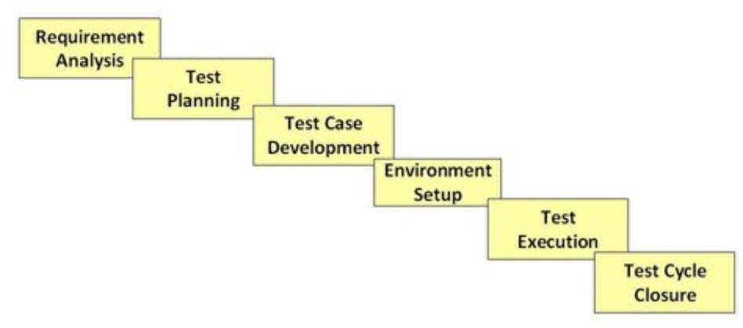

1. Requirement Analysis- High-level analysis of the requirement given in the documents, to understand the size and functional scope of the application
2. Test Plan - Having an overview of in scope and out scopes functionalities, objectives, test strategy, and deliverables
3. Test case development - Using test techniques like Equivalence Class Partitioning and Boundary Value Analysis (BVA) I have created the test cases.
4. Environment Setup- Testing the application on my local with a specific version of browsers.
5. Test Execution - Execution with both manual and automation.
6. Test Cycler Closure- All the planned test cases are executed and I have provided the reports.

TESTING METRICS

* + 1. **No. of test cases planned vs executed**

|  |  |  |
| --- | --- | --- |
| **Test Cases Planned** | **Test Cases Executed** | **Test Cases Deferred** |
| 35 | 35 | 0 |

* + 1. **No. of test cases passed/failed**

|  |  |
| --- | --- |
| Test Cases Passed | Test Cases Failed |
| 20 | 15 |

* + 1. **No. of defects identified and their Status & Severity**

|  |  |  |  |  |  |
| --- | --- | --- | --- | --- | --- |
|  | Critical | High | Medium | Low | Total |
| Open | 0 | 2 | 1 | 12 | 15 |
| Total | 0 | 2 | 1 | 12 | 15 |

RISKS

1. The User can add empty articles, there is no validation.
2. There is no verification of the email id, an anonymous user can create the account.
3. No validation on the sign-up page for the password, as an account can be created without any password. Due to this users cannot login again one he/she is logged out. Due to this, we lose our users.
4. Not optimized for mobile web.
5. 404 error pages should be included when the user tries to manipulate the URL.
6. The review process for the article comment should be implemented.
7. Before publishing the articles admin approval process should be implemented.

TEST TOOLS

1. Test Automation: Protractor, Functional testing
2. Test Tools: Google sheet, qtest
3. IDE: Visual Studio Code
4. Version Control: Github

RECOMMENDATIONS

1. The application is responsive, but it could be managed in proper way.
2. On the sign-in and Sign up screen when the user hits enter button then functionality should work as expected.
3. Image resizing should there.
4. Forget password is a miss.
5. Limit of text should be used, length of data should be restricted while creating the post.
6. Popular tags should be listed on the basis of the most used tags on the top and the least used tag below.
7. The review process for the article comment should be implemented.
8. Before publishing the articles admin approval process should be implemented.
9. 404 error pages should be included when the user tries to manipulate the URL.

EXIT CRITERIA

* All Designed Tests cases are executed.
* Major functionality is tested.
* The Failure percentage is more than 40%.